The Axis2 client programming model was developed in a way that it will support both synchronous and asynchronous web service invocation, with the following five types of client programming models. The client side architecture with invocation paths are shown in Figure 1.

- One way invocation with two way transport
- Fire and forget invocation
- Two way invocation with two way transport
- Asynchronous invocation with two way transport
- Asynchronous invocation with one way transport

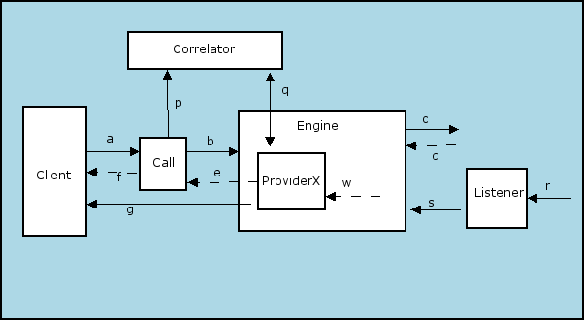

Figure 1 – Axis Client Architecture

Client
The client side application is known as the Client.

Call
The API that Axis2 provides to invoke any type of web service is Call. It consists of the following methods.

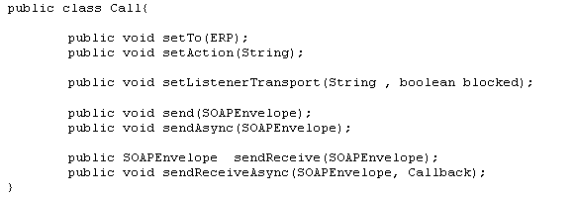

Engine
The engine is the actual axis engine. There is no difference between the server side Axis engine and the Client side axis engine. Both work in a similar way.

Correlator
The Correlator is required when the client programming model is asynchronous. It stores the callback object with the key field as messageID. This is a singleton class which consists of the following two methods;

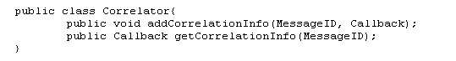
Listener
The listener is nothing but a server socket listening to a specific port. This component is only used when the client programming model is asynchronous with one way transport. More details are described later in the report.

ProviderX
This is a special kind of client side provider similar to the server side provider. This is only used when there is a response.

One way invocation with two way transport
This type of Client programming model does not wait for a response, it sends the message and only cares about either the acknowledgment or the SOAP fault. In the axis engine only the handler that belongs to IN paths in the client side will be invoked. In Axis2 invocation consists of the following steps.
- Create a call object.
- Using either the OM or use a different method to create a SOAPEnvelope.
- Call the send method passing the created envelop as an argument.
The code snippet for invoking a web service in this type of client programming model and message path according to Figure 1 is as follows and the corresponding sequence diagram is shown in Figure 2;

call.setTo(EPR)
call.setAction(String)
call.send(SOAPEnvelope)

Message path
a -> call.send(SOAPEnvelope)
b -> engine.send( ..)
c -> Send the SOAP message

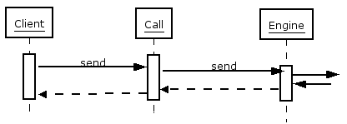

Figure 2- Sequence diagram for send ()

Fire and forget invocation
The only difference between this type of invocation and the one way invocation with two way transport is that this invocation method does not wait for the acknowledgment. This programming model can be used with both one way and two way transport. In the axis engine only the handler that belongs to IN paths in the client side will be invoked .The Code snippet and message paths according to Figure 1 are described below. The corresponding sequence diagram is shown in Figure 3.

call.setTo(EPR)
call.setAction(String)
call.sendSync(SOAPEnvelope)

Message paths
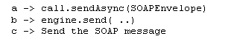

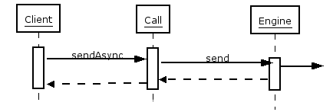
Figure 3 – Sequence diagram for sendAsync()

Two way invocation with two way transport
In this method of invocation the client accepts a response and hangs until it gets the response. Only one transport is used for both outgoing and incoming messages. Each and every handler in both the IN and OUT paths in the axis engine will be invoked. In the IN path the engine first invokes all the handlers and then the Message context that corresponds to the incoming message hands over to ProviderX (client side provider), which does the encoding and all the required functionalities. Finally the object that the client application is expecting will be provided to the Client application. It should be noted that in this invocation method, that one engine instance will process both the incoming and outgoing message. Corresponding code snippet and message paths are described below and related sequence diagram is shown in Figure 4.

call.setTO(URL)
call.setAction(String)
SOAPEnvelope env=call.sendReceive(SOAPEnvelope)

Message paths
a -> call.sendReceive(SOAPEnvelope)
b- > engine.send (..)
c -> Send the SOAP message
d -> Receive the response over the synchronous transport
w -> ProviderX will be called as the last step in engine.receive(..)
e -> provider returns
f -> Call hand over the response to the client

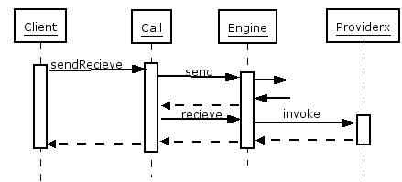
Figure 4 – Sequence diagram for sendRecieve()

Asynchronous invocation with two way transport
In this type of client programming model the client does not hang until it gets the response, but the underlying transport waits until it gets that. Here the outgoing and incoming message are handle using the one engine instance as two engine instances are not created for the IN and OUT. However for two concurrent outgoing messages it creates two engine instances. The invocation is a bit different compared to the above discussed programming models; here the callback concept is comes into play. The Client should first create a callback object by implementing the onComplete () method in a manner that he/she wants. Next the SOAPMessage and the callback object are passed as arguments to the sendRecieveAsync() method, after which the created callback object and the messageID gets added to the Correlator by the call object .Then the engine sends the message to the specified server (it is specified by setTO ) and waits for the response. When the engine receives the response it invokes the engine.receive() method, invokes all of its handlers and finally hands it over to ProviderX and takes the corresponding callback object from the Correlator using the messageID and calls its onComplete method of callback object. The Corresponding sequence diagram is shown in Figure 5. The code snippet and message paths are shown below;

call.setTO(EPR)
call.setAction(String)
call.setListenerTransport(“http”, true)
call.sendReceiveAsync (SOAPEnvelope, Callback)

N.B: in setListenerTransport(“http”, true) , is used to indicate that the underline transport is http and it should use same transport for both outgoing and incoming messages. If the boolean value is false that means outgoing transport dose not wait for incoming message and for the incoming message it should be created a correct transport by call object.

Message paths

a -> call.sendReceiveAsync (SOAPEnvelope, callbackObj)
p -> correlator.addCorrelationInfor(msgID,allbackObjRef)
b- > engine.send (..)
c -> Send the SOAP message
d -> Receive the response over the synchronous transport
w -> ProviderX will be called as the last step in engine.receive(..)
q -> correlator.getCorrelationInfo(msgID)
g -> callbackObj.onComplet()

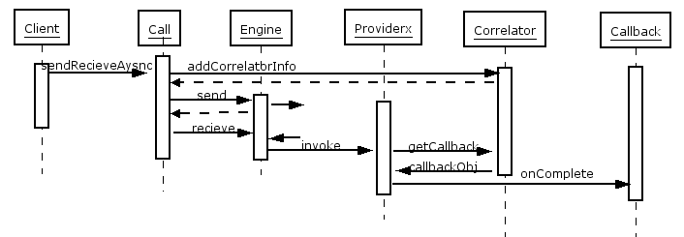
Figure 5 – Sequence diagram for sendRecieveAysn with two way transport

Asynchronous invocation with one way transport
This programming model is almost similar to the asynchronous invocation with two way transport, the exception been that the outgoing and incoming messages use two engine instances and that the outgoing transport does not wait for a response. Instead the corresponding incoming message is processed by a different transport which is created by a call object while it is sending the request. Here the Listener is the newly created transport, which is a socket opening and running to gets the incoming message. The Corresponding sequence diagram is shown in Figure 6. The code snippet and message paths are described below.

call.setTO(EPR)
call.setAction(String)
call.setListenerTransport(“http”, false)
call.sendReceiveAsync(SOAPEnvelope, Callback)

Message paths

a -> call.sendReceiveAsync (SOAPEnvelope, callbackObj)
p -> correlator.addCorrelationInfor(msgID,allbackObjRef)
b- > engine.send (..)
c -> Send the SOAP message
r -> Receive the response by the listener
s -> engine.receive(..)
w -> ProviderX will be called as the last step in engine.receive(..)
q -> correlator.getCorrelationInfo(msgID)
g -> callbackObj.onComplet()

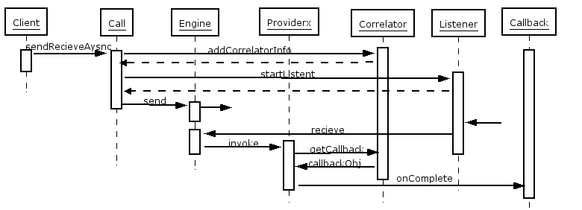
Figure 6 – Sequence diagram for sendRecieveAync with one way transport.

